**Analog Signal and Digital Signal**

**Aim:** To design two circuits for Analog Signal and Digital Signal

**Circuit Diagram for Analog Signal**: Amplitude Modulation

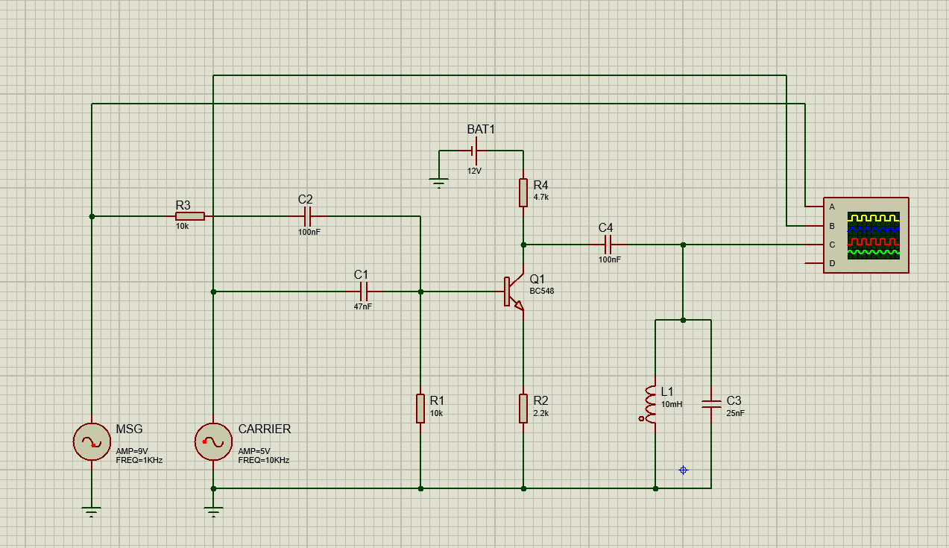

**Output:**

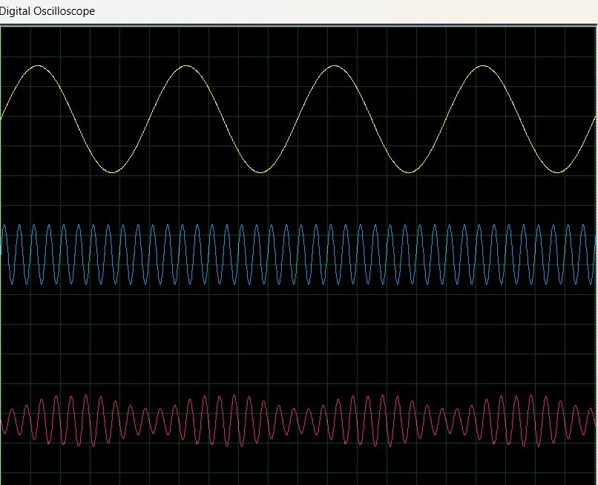

**Circuit Diagram for Digital Signal:** Amplitude Shift keying

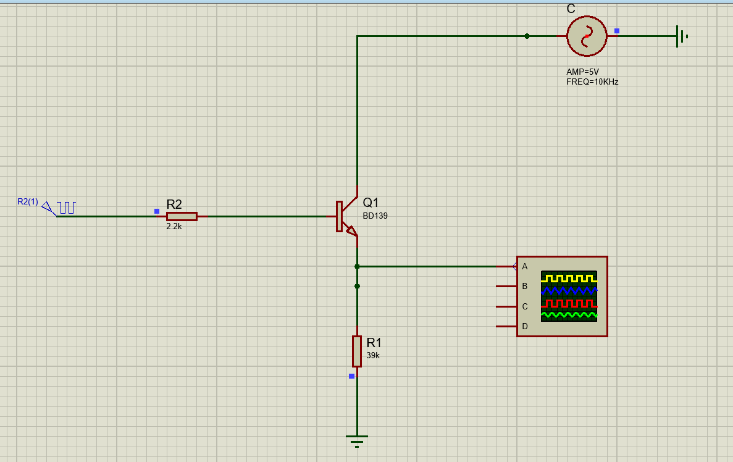

Output:

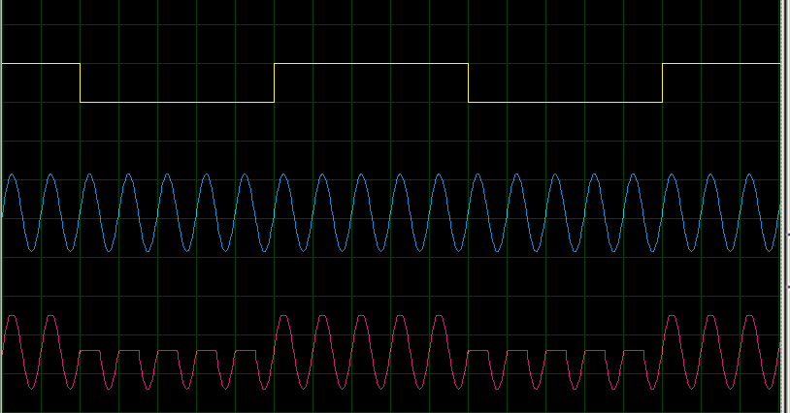

**Theory:**

